

Roadkill Hotspots
&
Policy Advocacy
Ideathon Project Documentation
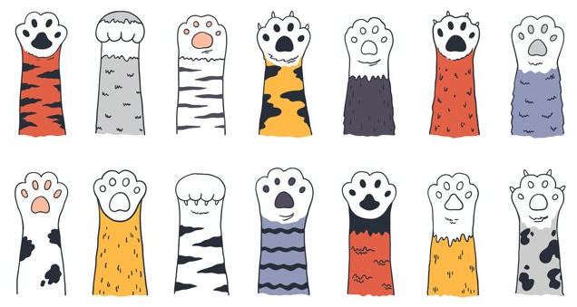

Lokesh Patra | FET-BDS-2022-26-020

Indigibilli Harshit | FET-BDS-2022-26-015

Table of Contents
- Abstract
  - Overview of the Roadkill Problem
  - AI and IoT-Based Solution
    - Multilayered Approach
- Introduction
2.1 Background & Theme
2.2 Objective
2.3 Multilayered Approach
- Technology Stack
3.1 AI-Based Animal Detection (YOLOv5xu)
3.2 CNN-Based Dead/Alive Classification
3.3 IoT Integration for Real-Time Alerts
- System Design & Implementation
4.1 AI-Based Roadkill Detection (D1 & D2)
4.2 IoT-Based Real-Time Alerts (D3)
4.3 Data Collection for Heatmap & Policy Advocacy
- Evaluation & Results
5.1 AI Model Performance
5.2 Real-Time Testing & Deployment
- Policy Advocacy & Future Scope
6.1 Policy Recommendations
6.2 Future Enhancements
- Conclusion
- References

Abstract
Roadkill incidents pose a significant threat to wildlife, with thousands of animals dying due to vehicle collisions every year. This project introduces an AI-driven solution to detect high-risk animal crossings using YOLOv5xu for object detection and DenseNet /EfficientNet-based CNN models for classifying dead or, alive animals.
The system integrates IoT sensors (ESP32, ultrasonic, DHT) for real-time monitoring and driver alerts. Additionally, heatmaps and predictive analytics are employed to identify roadkill hotspots and drive policy changes for safer roads.
The project follows a multilayered approach consisting of three dimensions:
- D1: Computer Vision (YOLOv5xu) – Detects animals, movement speed, and classifies risk.
- D2: ML Model (DenseNet + EfficientNet) – Determines if the detected animal is dead or alive.
- D3: IoT-Based System (ESP32, Ultrasonic Sensors) – Alerts drivers in real-time when an animal is detected.
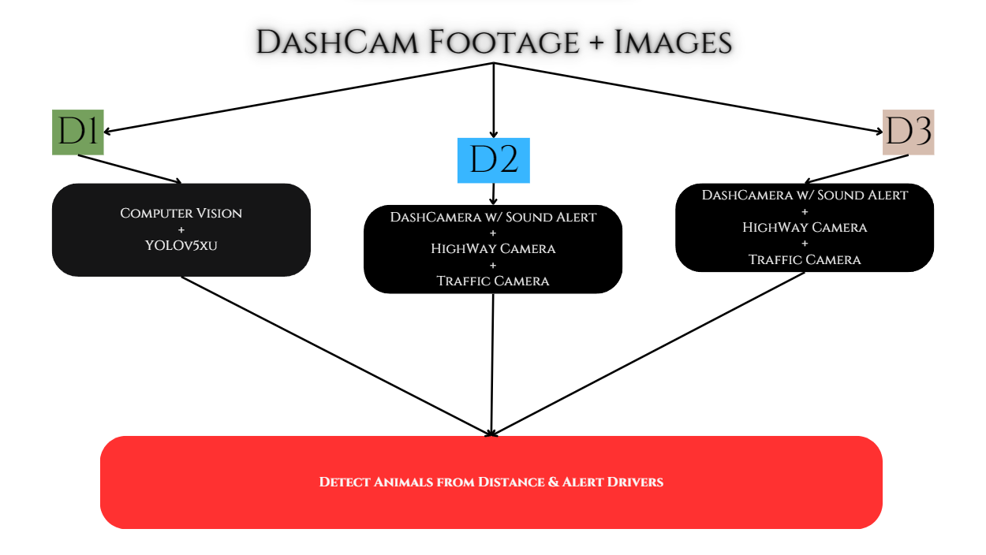

Figure 1 Flow Chart of Multilayered Approach [ 3Dimensions ]

1. Introduction
1.1 Background & Theme
With increasing urbanization and expanding road networks, stray and wild animals frequently encounter vehicles, leading to fatal accidents.
In some regions, studies have reported over 300+ roadkill cases within 10 months, significantly impacting biodiversity.
  - Objective
The aim of this project is to:
- Detect animals on roads in real-time using computer vision (YOLOv5xu).
- Classify if the detected animal is alive or dead ( CNN-based models).
- Predict risk levels using optical flow-based movement tracking.
- Warn drivers in real-time through IoT-based smart signage.
- Generate heatmaps of high-risk roadkill zones to inform policy makers.
1.3 Multilayered Approach
This project implements a three-dimensional AI-based solution for real-time roadkill prevention:
🔹 D1: Computer Vision (YOLOv5xu)
- Detects animals & objects in real-time.
- Identifies if the animal is dead or alive.
- Tracks animal movement speed.
- Detects high-risk sudden movements.
🔹 D2: ML Model (DenseNet + EfficientNet)
- Classifies animals as dead or alive and alerts the driver.
- Achieves 94%-98% accuracy with DenseNet & EfficientNet.
- Integrated with a Flask-based web interface for real-time processing.
🔹 D3: IoT-Based System (ESP32, Ultrasonic Sensors)
- ESP32 + Ultrasonic Sensor detects obstacles near highways.
- Smart signage with LED and buzzer system warns drivers when an animal is nearby.
- DHT Sensor measures temperature & humidity for environmental impact analysis.

2. Technology Stack
2.1 AI-Based Animal Detection (YOLOv5xu)
- Trained on real-world highway videos and images.
- Detects species, movement, and risk level.
- Integrated with Farneback Optical Flow to estimate speed and behaviour.
- Deployed 5 interfaces via Gradio each with a different processing power.
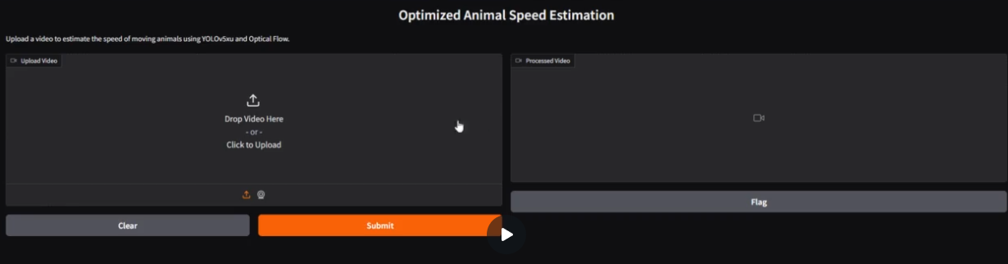

0: 384x640 2 cars, 628.3ms
Speed: 2.5ms preprocess, 628.3ms inference, 1.2ms postprocess per image at shape (1, 3, 384, 640)
High-Risk Animal Detected! Sending Alert...

0: 384x640 1 car, 630.3ms
Speed: 1.5ms preprocess, 630.3ms inference, 1.2ms postprocess per image at shape (1, 3, 384, 640)

0: 384x640 2 cars, 672.8ms
Speed: 1.9ms preprocess, 672.8ms inference, 1.2ms postprocess per image at shape (1, 3, 384, 640)
High-Risk Animal Detected! Sending Alert...

0: 384x640 2 cars, 647.7ms
Speed: 2.3ms preprocess, 647.7ms inference, 1.2ms postprocess per image at shape (1, 3, 384, 640)
High-Risk Animal Detected! Sending Alert...
Figure 2 Beep Alert Sound whenever Animal is detected!

2.2 CNN-Based Dead/Alive Classification
- Uses DenseNet121 and EfficientNet-B3 with 94-98% accuracy.
- L2 Regularization and Dropout used to prevent overfitting.
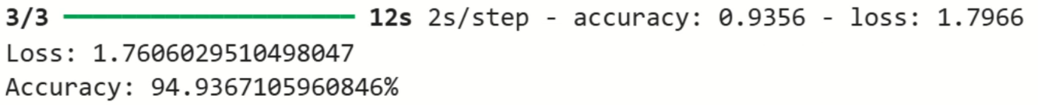
- Deployed via Flask API for real-time classification.

Figure 3 DenseNet-121 Loss & Accuracy
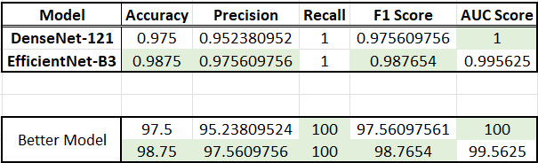

Figure 4 DenseNet121 + EfficientNetB3 Trained & Built Simultaneously

2.3 IoT Integration for Real-Time Alerts
- ESP32 Module processes YOLOv5xu output.
- Ultrasonic sensor detects object proximity.
- If an animal is detected, buzzer + LED warning system alerts drivers.

3. System Design & Implementation
3.1 AI-Based Roadkill Detection (D1 & D2)
Step 1: Capture video feed using dashcams, traffic cameras, or highway surveillance.
Step 2: Apply YOLOv5xu to detect animals and classify them as High Risk if sudden movements are detected.
Step 3: If the animal is stationary, CNN-based dead/alive classifier analyses the situation.
Step 4: If the animal is alive, trigger IoT-based alert systems for vehicles.
Step 5: If flatlined, an alert notification is sent to CMC ( Municipal Corporation ), for disposal of the body.

3.2 IoT-Based Real-Time Alerts (D3)
- ESP32 + Ultrasonic Sensor detects nearby movement.
- Smart signage with LED and buzzer system warns approaching vehicles.
- Data is sent to a central database for future roadkill pattern analysis.
3.3 Data Collection for Heatmap & Policy Advocacy
- Every detection event is logged into a Firebase database.
- Heatmap analysis is conducted to identify roadkill hotspots.
- Authorities are provided with real-time data dashboards to implement mitigation measures.

4. Evaluation & Results
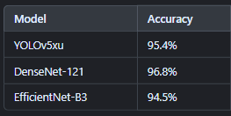
4.1 AI Model Performance

Figure 5 Model Comparison [Accuracy ]
4.2 Real-Time Testing & Deployment
- AI models successfully identified animals in videos with 95% accuracy.
- IoT alerts triggered within 500ms of detection, ensuring quick response time.
- Heatmap analysis showed repeated hotspots, validating the need for policy changes.

5. Policy Advocacy & Future Scope
5.1 Policy Recommendations
- Mandatory AI-powered dashcams in vehicles for wildlife-prone roads.
- Smart signage systems to alert drivers in real-time.
- Collaborations with governments & automobile companies to integrate AI-based roadkill prevention.
5.2 Future Enhancements
- Edge AI & TinyML integration for low-power real-time inference.
- 5G connectivity for faster data transmission & cloud integration.
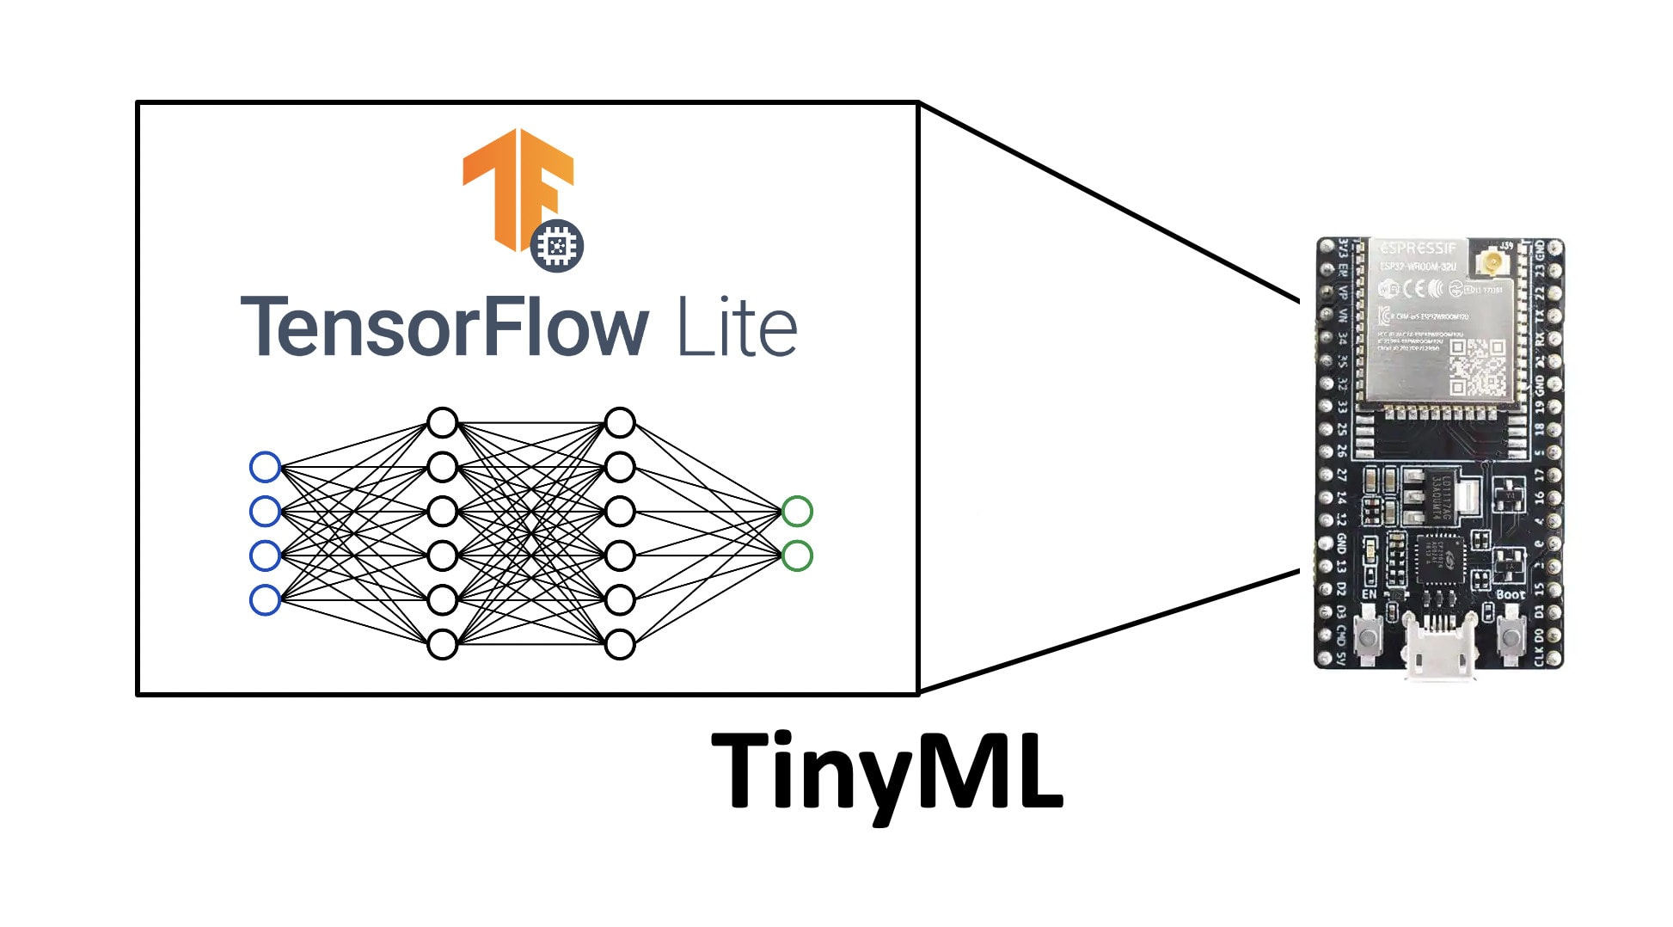
- Autonomous vehicle compatibility to auto-brake when an animal is detected.
Figure 6 IoT Automation in Vehicles w/ TinyML

6. Conclusion
This project successfully integrates AI, IoT, and policy advocacy to minimize roadkill incidents. By detecting animals in real time, classifying their condition, and alerting drivers, this system can significantly reduce accidents and save wildlife. The predictive analytics-based heatmaps further ensure that authorities take preventive measures. With further improvements, this system can be deployed globally to protect both human and animal lives.

7. References
[1] Research Paper on Roadkill Incidents and Their Impact on Biodiversity.
[2] OpenCV Documentation for Optical Flow-based Motion Tracking.
[3] YOLOv5 Official Repository & Research Papers on Object Detection.
[4] EfficientNet & DenseNet Research Papers on Image Classification.
[5] IoT-Based Traffic Monitoring & Smart Signage Research.



Thank You!
Team Saviors

